POWER BI ASSIGNMENT 1
1.What do you mean by BI? Explain.
Business intelligence is a technology-driven process for analysing data and delivering actionable information that helps executives, managers and workers make informed business decisions. It is responsible for taking the data that a company holds and mining it to achieve valuable insights. These insights are then used to inform critical business decisions. The insights play a crucial role in shaping the company's future and the way it operates. It is a means of performing descriptive analysis of data using technology and skills to make informed business decisions. The set of tools used for BI collects, governs, and transforms data.
The whole process of business intelligence can be divided into four stages:
Data gathering, Data cleaning/standardization, Analysis, Reporting
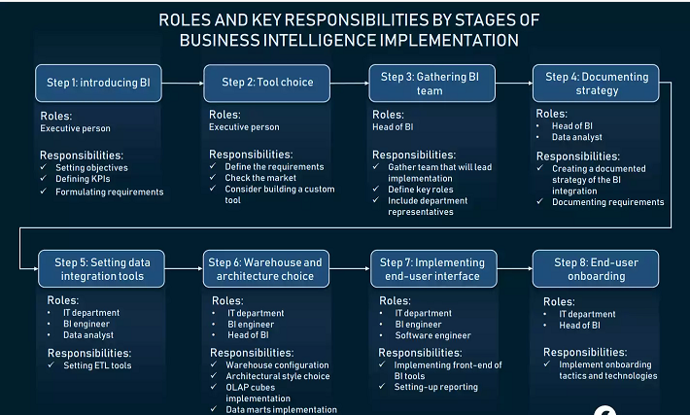

1.How Power-BI helps in BI, and how does it help Analysts? Explain.
One of the main strengths of Power BI is its intuitive user interface that allows both technical and non-technical analysts to build data visualizations and analyses efficiently. The user-friendly drag-and-drop interface makes it easy to answer complex data-related questions without the need for programming skills.
Power BI extract data insights with no coding skills required
Democratize data insights with dashboards
Power BI allows users to string together a series of visualizations (including dashboards) to form a visual story to communicate data insights, provide context, and demonstrate how decisions relate to outcomes.

2.Explain Descriptive analytics?
Data analytical approach, answering the questions what was happening? and what is happening? This type of data processing is also called descriptive analytics. With the help of descriptive analytics, businesses can study the market conditions of their industry, as well as their internal processes. Descriptive, which answers the question, “What happened?”
3.Explain Predictive analytics?
Predictive analytics is concerned with forecasting based on data processing of past events. Instead of producing overviews of historical events, predictive analysis makes forecasts about future business trends. Those predictions are based on past events analysis. So, both BI and predictive analysis can use the same techniques to process data. To some extent, predictive analytics can be considered the next stage of business intelligence. Predictive, which answers the question, “What might happen in the future?”
4.Explain perspective analytics?
Prescriptive analytics is the third type that aims at finding solutions to business problems and suggests the actions to solve them.This type of analysis goes beyond explanations and predictions to recommend the best course of action moving forward. It’s especially useful in driving data-informed decision-making. Prescriptive, which answers the question, “What should we do next?”
5.Write five real-life questions that PowerBi can solve.
- Power BI allows you to access your company's data analytics almost instantly. On top of that, it also makes the data easy to decipher with advanced visualizations which can be shared at the touch of a button.
- Power BI reduces the possibility of error by allowing reports to be run in seconds using only the most current data. This ensures that reports can’t be altered or deleted and eliminates the time spent sifting through files to find the correct data.
- Power BI can quickly and easily create visual representations of your data and provide stunning and accurate presentations for your meetings. Using Power BI’s automated reporting tools can save hours of preparation.
- Power BI allows IT members to publish data catalogs for others to view. This makes it easier for you to find the data sets needed to perform an analysis. Additionally, using natural language technology and its Question & Answer feature provides a more natural experience
- Power BI solutions that can make company’s day-to-day activity far more efficient, tech-savvy, and less frustrating for company’s and company employees.

